The folowing is a 2x2 cross table comparing the prevalence of Parkinson’s disease amongst Males and Females

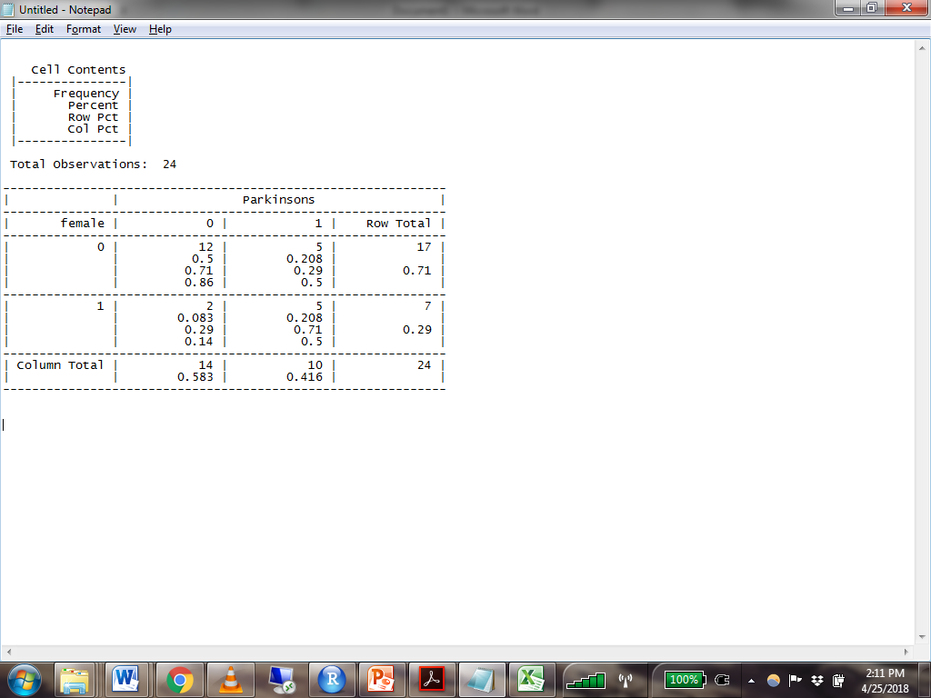

1. What is the probability of having Parkinson’s for females?
2. What is the probability of having Parkinson’s for males?
3. What is the risk ratio of having Parkinson’s for males compared to females?
4. What are the odds of having Parkinson’s for females?
5. What are the odds of having Parkinson’s for males?
6. What is the odds ratio of having Parkinson’s for females compared to males?